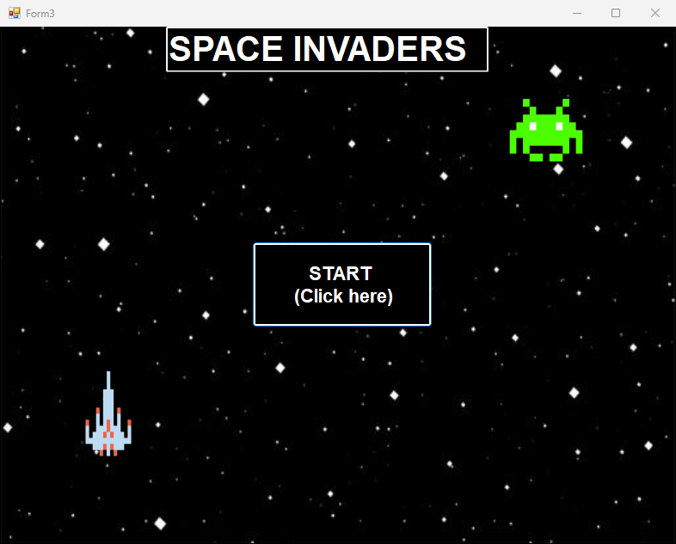

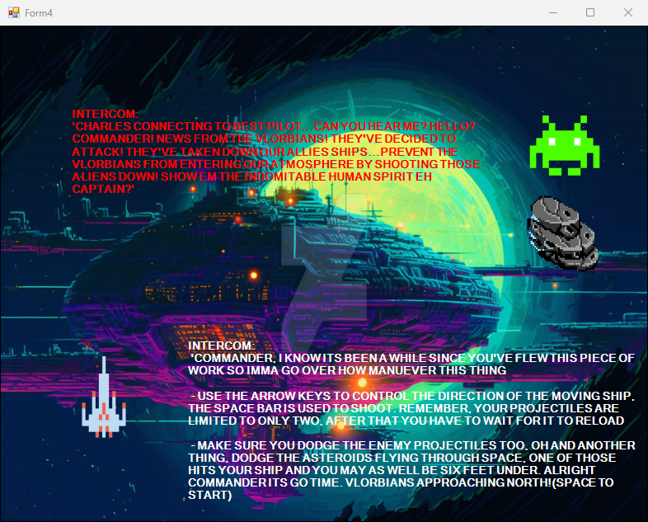

The program works as intended

A few bugs is that when the form is resized the old image of victory and game over still remains on the screen.

